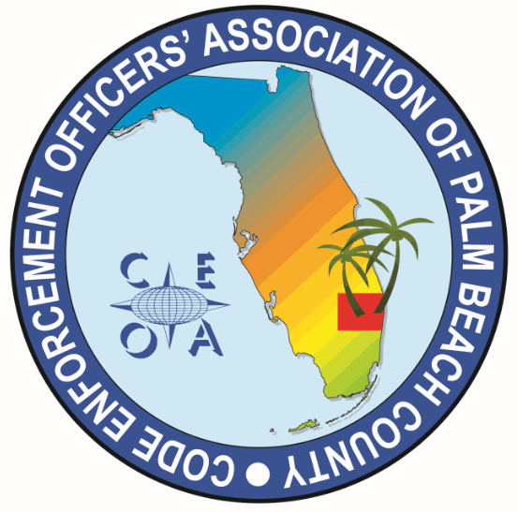

CODE ENFORCEMENT OFFICERS ASSOCIATION OF PALM BEACH COUNTY
BOARD MEETING AGENDA
FEBRUARY 9, 2026
11:00 AM
EATALIA
7784 OKEECHOBEE BLVD WEST PALM BEACH, FL 33411

CALL MEETING TO ORDER, ROLL CALL, ESTABLISH A QOURUM, RULES OF MEETING

APPROVAL OF THE NOVEMBER 14, 2025 MEETING MINUTES – MICHELLE MALKIN-DANIELS

TREASURER REPORT – JOE OLIVA

OLD BUSINESS

- BYLAW REVIEW COMMITTEE UPDATE – DWAYNE JOHNSON

- CONSIDERATION TO SEND VP, SONJA BINNS TO THE ICC LEADERSHIP ACADEMY IN HARTFORD, CONNECTICUT APRIL 16TH THROUGH 19TH

NEW BUSINESS

- MARCH 11TH ANNUAL MEETING, LUNCHEON, TWO-HOUR TRAINING AND ELECTIONS, 8:00 AM TO 3:00 PM AT THE CITY OF PALM BEACH GARDENS

- F.A.C.E CONFRENCE JUNE 9TH THROUGH 12TH KISSIMMEE FLORIDA
- CONSIDERATION TO SEND PRESIDENT TO F.A.C.E. CONFRENCE
- DISCUSSION OF THE RAFFLE TABLE AT CONFRENCE
- PICK A COOLER TO BE RAFFLED OFF AT CONFRENCE
- CONSIDERATION OF RAFFLE TICKET PRICING

- DISCUSSION REGARDING “15 MINUTE RULE” FOR RECEIVING CREDITS AT TRAINING BLOCKS

- ITEMS TO BE CONSIDERED FOR NEXT MEETING AGENDA

- SET NEXT MEETING DATE AND TIME

ADJOURNMENT

